Project Objectives:
The purpose of this project is to give students hands on experience in a “close to real” database application. Understand the overall database application architecture, design issues and trade offs. Lean how to connect to database, construct and use SQL queries in the context of a programming language. At the end of this project, students should achieve the following objectives:
- Learn to design database application within a given framework, such as, three-tire architecture vs. two-tire application architecture.
- Design and develop simple graphic user interfaces.
- Learn component design and develop some basic re-useable components.
- Lean to use open database connection (ADO.Net or JDBC) and SQL in the context of programs.
- Produce a working system that can perform a set of simple functions.

Project Description:
Design and develop an online application system that supports your business operations. Each application need to include the following required functions.
- User Login/Registration management
- 3 major business functions in your business area
- Using database as your major data source.

Project Development Framework

Three-tier Application Architecture: Graphical User Interface, Business logic components, Database
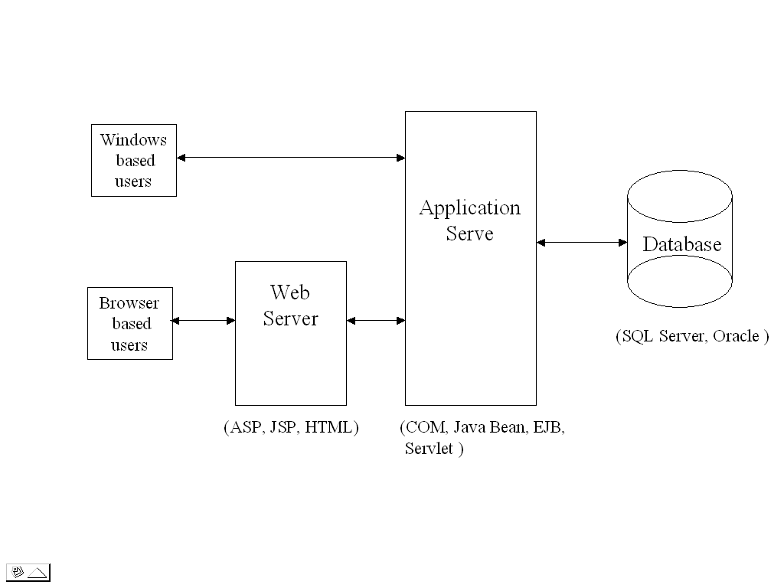

Graphical User Interface – It can be either window-based or browser based interface on Microsoft windows platform.

Business Logic Components – It can be Microsoft COM or .Net component or Java Beans or EJB component.

Database – Microsoft SQL Server or MySQL

Programming Languages - Preferred programming languages are Visual Basic or ASP. But students can have the choice to use Java, JSP for their development if they feel they are well equipped with Java programming knowledge and skills. Program sample codes are only in Visual Basic or ASP.

Project Requirement Deliverable

In order to fully consider and evaluate the project, each project team need to provide the following project documents:
- Design and develop a E-R data model, relational scheme for the project and implement the E-College database in a relational database. MySQL preferred.
- System Design Document – includes diagram of application architecture indicate the application platform. Prototype user interface and functions. List components and their functions. Map program components to Database schemas (tables)
- Business test case and script - That can demo the functions of your system.
- Document and list program source code.
- Write an installation guide document as how to setup your applications.

Project Structure, timeline and Resource

Project team – Each project team can have 2-3 persons (maximum 3). One person will be the team lead to coordinate the team activity and responsible for the team to meet all the project deliverable timeline.

Project Deliverables
- Project data model, schema and data base implementation (DDL)
- System design document.
- Business test case/script document .
- Installation guide document.
- Program source code and documents
- Program Demo and presentation.

Project Resource – Project materials and sample codes will be provided during the project. Lab hours and individual team consultation will be provided during lab and office hours.

